SkateGuard — 6-Week Project Report
Oct 2, 2026 · @Someone
SkateGuard counts kickflip lands and bails, tracks speed, distance and route, and serves its own dashboard from the board to the rider's phone over a hotspot, with a wrist unit showing live speed and the dashboard address. Weeks 1 to 5 were delivered in full and Week 6 is under way, with four design changes made during the build: a BNO055 IMU in place of the MPU6050, ESP-NOW plus a self-hosted web dashboard in place of BLE and a companion app, oscillation-based wobble detection in place of a 25 km/h speed trigger, and bails judged by how the deck settles rather than by an impact spike. This report follows the plan week by week.

At a glance
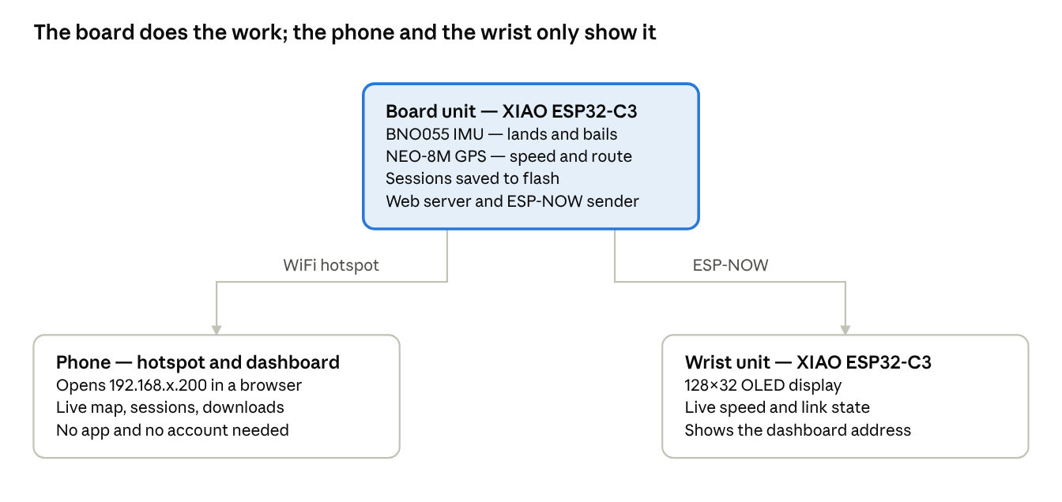
system overview · board, phone, wrist
The board is the only part that senses, decides and stores; the phone and the wrist are displays. Nothing leaves the rider's hotspot, so the system works with no mobile data and no account.

The six weeks at a glance
Every week's objective was met, several by a different route than planned. Changes from the original plan, near the end of this report, sets out each change and why it was made.
Week | Planned | Delivered
1 | Finalise layout, lock the wobble threshold at 25 km/h, confirm the Kickflip approach, procure ESP32, MPU6050, GPS, BLE wearable parts, motor, battery | Layout fixed: board unit under the deck, wrist unit on the strap. Parts bought around two XIAO ESP32-C3 boards, a BNO055 IMU and a NEO-8M GPS. Wobble redefined as an oscillation pattern rather than a speed trigger
2 | Mechanical layout, 3D-printed board housing and wrist casing, ESP32 toolchain, basic IMU and GPS communication | Both enclosures built. Arduino IDE with ESP32 core 3.2.0 on XIAO_ESP32C3, IMU reading over I2C and GPS over UART1 at 9600 baud
3 | Firmware reading live IMU and GPS, wobble algorithm with the 25 km/h gate, Kickflip detection from rotational signatures | Main loop reading both sensors continuously. Kickflip detection built as a four-stage state machine on the gyro's Y axis. Wobble detection built on counted oscillations, with no speed gate
4 | BLE between board and wearable, haptic feedback on wobble, bail detection from impact spikes, land versus bail classification | ESP-NOW link between the two boards, with channel hunting. Land and bail separated by how the deck settles after the rotation, not by an impact spike
5 | Companion app or dashboard, GPS route mapping, ride statistics, post-ride summary, live sync over BLE | Dashboard served by the board itself over the phone hotspot: live readout, route map, session list, per-session CSV and route-map download
6 | Full system testing across speeds and surfaces, tune sensitivity, finalise accuracy, final assembly, demonstration and documentation | Firmware, dashboard and both enclosures assembled and running. Bench and browser testing complete; on-road tuning of detection sensitivity is in progress

Week 1 — Foundation and design
Planned: finalise the prototype layout, lock the wobble threshold, confirm the kickflip approach and procure the hardware.
Delivered: the layout and the detection approach were fixed, and the parts list was bought around two XIAO ESP32-C3 boards.
- Board unit mounted under the deck on a plate that bolts around the truck baseplate; wrist unit on a strap.
- Parts: two Seeed XIAO ESP32-C3 boards, a BNO055 IMU, a NEO-8M GPS, an SSD1306 128×32 OLED, two 1500 mAh lithium cells, two USB-C charging modules, a vibration motor and indicator LEDs.
- Kickflip detection scoped to rotation on one gyro axis, with the landing judged by how the deck settles rather than by an impact spike.
- Wobble redefined as a counted oscillation pattern instead of a 25 km/h speed trigger, for the reasons in Changes from the original plan.

CAD design
Both enclosures were designed in CAD before anything was printed, so component clearances, port positions and the mounting pattern were settled on screen rather than in filament.
Both units are 3D-printed, two-part enclosures that each hold their board, a lithium cell and a USB-C charging module, with every port and indicator reachable without opening the case.

Board unit
The board enclosure is a mounting plate that sits between the deck and the truck, with the hardware split into three compartments so each part gets what it needs: the GPS patch antenna faces up with a clear view of the sky, the IMU sits in its own pod on the plate's edge where it reads the deck's rotation directly, and the XIAO, cell and charging modules fill the opposite compartment. The oval and slotted cut-outs drop weight and clear the mounting bolts.
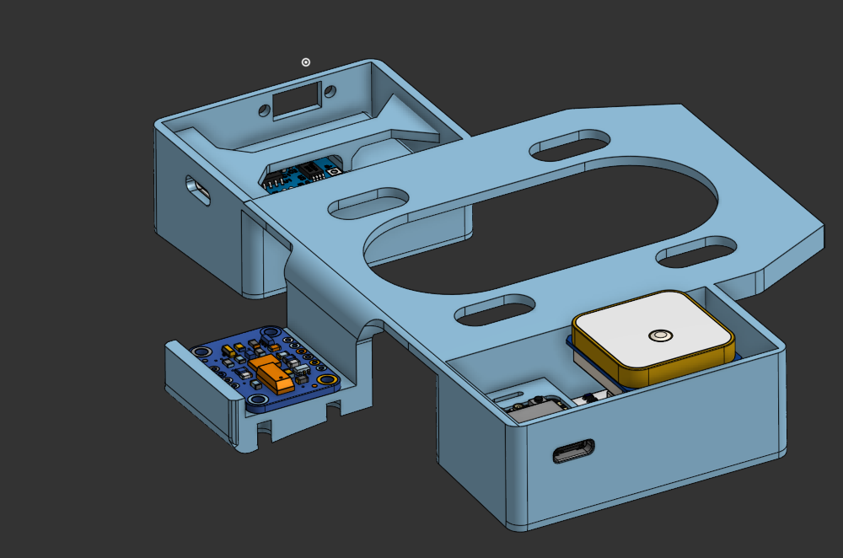
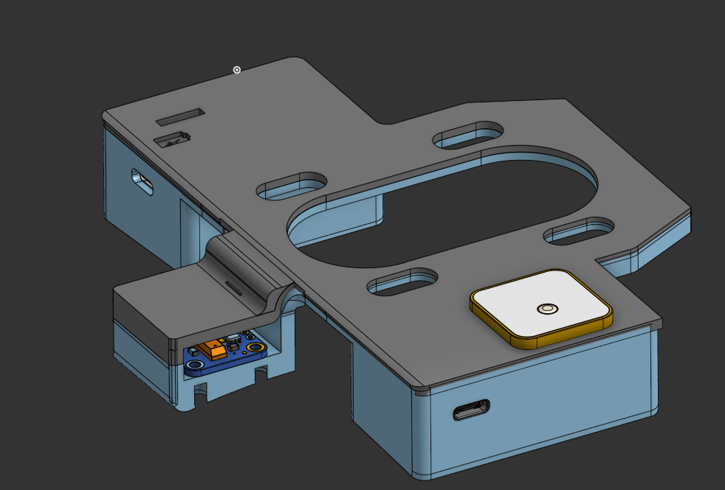
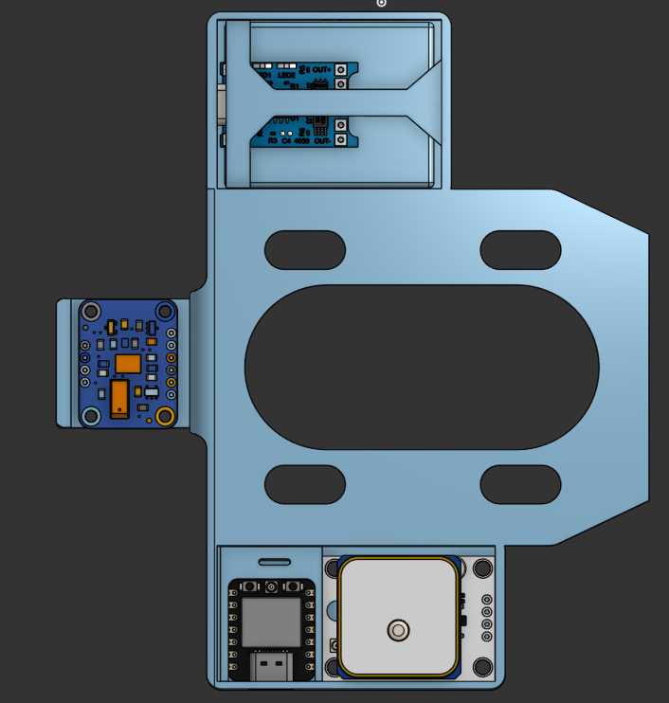
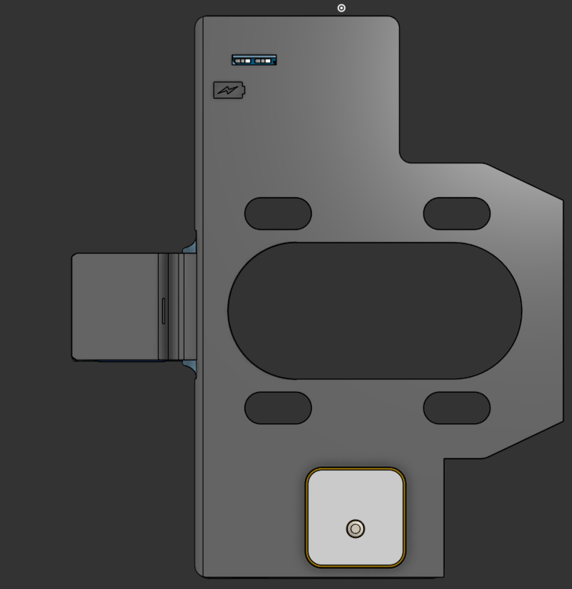

Wrist unit
The wrist enclosure is a lidded box with lugs at all four corners for the strap. The OLED sits in a window in the lid with its four pins (GND, VCC, SCL, SDA) running to the XIAO below, and the two indicator LEDs show through beneath it. The USB-C port of the charging module is recessed into the side wall, so the unit charges on the wrist without being opened.
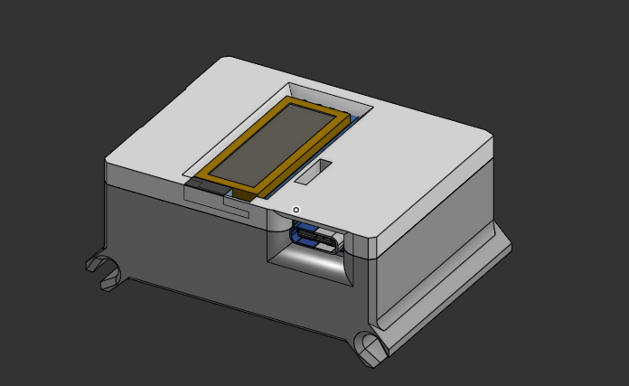
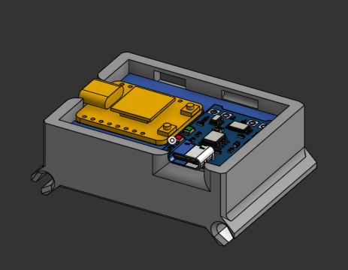
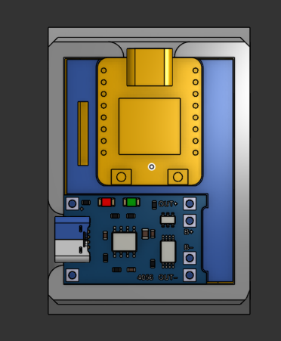
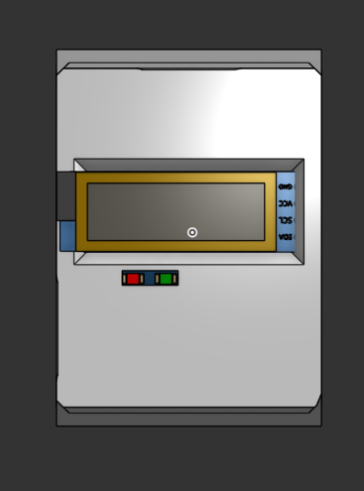
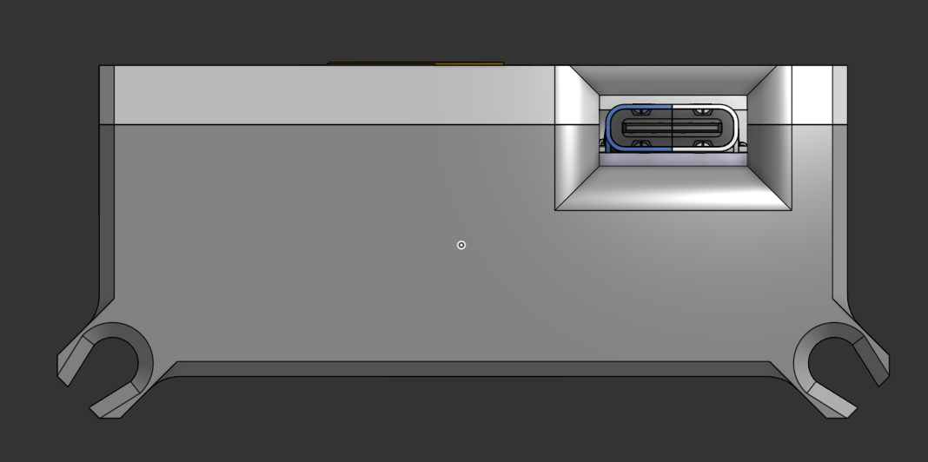

Week 2 — Hardware and enclosure
Planned: mechanical layout for the IMU and GPS, 3D-printed board housing and wrist casing, ESP32 toolchain, basic IMU and GPS communication.
Delivered: both enclosures printed and populated, the toolchain running on Arduino IDE with ESP32 core 3.2.0 on XIAO_ESP32C3, and both sensors talking to the board.
Both units are Seeed XIAO ESP32-C3 boards, so one toolchain and one radio stack covers the whole system.
Unit | Component | Connection
Board | Seeed XIAO ESP32-C3 | Mounted under the deck
Board | BNO055 IMU | I2C — SDA GPIO6 (D4), SCL GPIO7 (D5), address 0x28, fused mode
Board | NEO-8M GPS | UART1 — RX GPIO20, TX GPIO21, 9600 baud
Board | Battery sense | ADC GPIO4 (ADC1_CH4), divider 30k / 10k
Board | 1500 mAh lithium cell, USB-C charging module, slide switch | Cell to charger, charger output through the switch to the XIAO
Wrist | Seeed XIAO ESP32-C3 | Worn on the strap
Wrist | SSD1306 128×32 OLED | I2C — SDA GPIO6 (D4), SCL GPIO7 (D5), driven by U8g2
Wrist | Vibration motor | GPIO3
Wrist | Status LED | GPIO8
Wrist | Battery sense | ADC GPIO2 (D0), divider R1 = 30k / R2 = 10k, 11 dB attenuation
Wrist | 1500 mAh lithium cell, HW-373 V1.2 USB-C charging module, slide switch | Same arrangement as the board unit
Link | ESP-NOW broadcast | Channel follows the phone hotspot
The BNO055 runs its own sensor fusion, so the ESP32 reads finished Euler angles and a gyroscope vector instead of filtering raw accelerometer data itself. Battery voltage is averaged over several ADC reads, because a single read on this chip swings the reported percentage by several points.
The board sketch uses 91% of the default 1.25 MB program partition and 12% of RAM. Session data lives in a separate LittleFS partition, so a nearly full sketch cannot push the stored rides out.

Printed, populated and wired
The CAD in Week 1 came out as two printed enclosures, populated and mounted.
Built and mounted, the plate bolts around the truck baseplate with the IMU pod hanging off the deck's edge. The charging module, cell and power switch sit in the upper compartment, the XIAO and the GPS antenna in the lower one.
[image: The board unit bolted to the deck around the truck baseplate]
[image: The built plate off the deck: GPS antenna and XIAO, IMU breakout on its pod, charger, cell and switch]
The built unit uses an HW-373 V1.2 USB-C charging module (TP4056 class) stacked over the XIAO, with the OLED facing out through the lid.
[image: The built wrist unit: charging module, XIAO and OLED showing the battery icon]
[image: The wrist case with its lithium cell, lid and board removed]

Wiring
Each unit is wired the same way: the cell feeds a USB-C charging module, the module's output passes through a slide switch to the XIAO, and the sensors or display hang off the XIAO's I2C and UART pins. The resistors in each diagram are the I2C pull-ups and the indicator-LED series resistor. Both units run a 3.7 V 1500 mAh lithium cell; the capacities printed on the diagram artwork are stand-ins from the drawing tool.
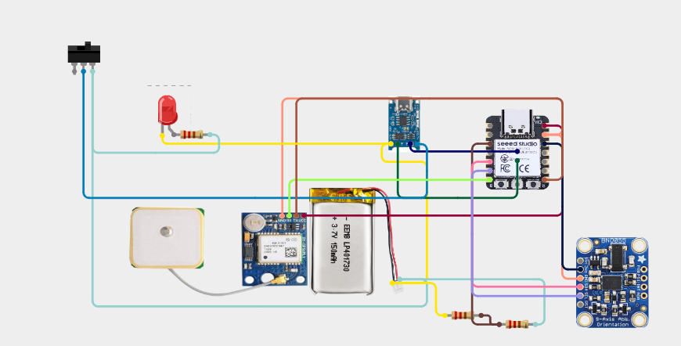
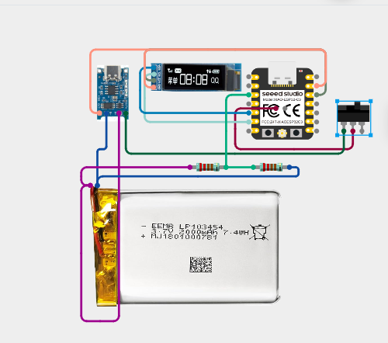
Signal | Board unit | Wrist unit
I2C data | GPIO6 (D4) to BNO055 | GPIO6 (D4) to OLED
I2C clock | GPIO7 (D5) to BNO055 | GPIO7 (D5) to OLED
Serial | GPIO20 RX, GPIO21 TX to NEO-8M at 9600 baud | —
Battery sense | GPIO4 (ADC1_CH4) through a 30k/10k divider | GPIO2 (D0) through a 30k/10k divider
Motor | — | GPIO3
Status LED | Indicator LED on the charging module | GPIO8
The I2C pins and the board unit's ADC pin are marked UNVERIFIED in the firmware, so confirm them against these diagrams before the pin table is treated as final.
Open question: the print material, layer height, infill and finished dimensions of each enclosure are not recorded yet.

Week 3 — Sensor and embedded system
Planned: firmware reading live IMU and GPS data, the wobble algorithm, and kickflip detection from rotational signatures.
Delivered: a continuous sensor loop, kickflip detection as a four-stage state machine, and wobble detection on counted oscillations.
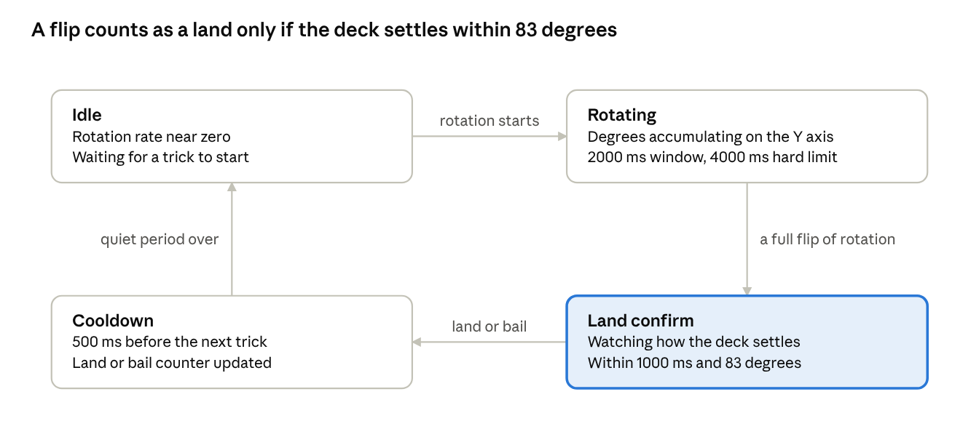
trick detection · four stages
A trick that reaches Land confirm and settles inside the limit counts as a land. One that keeps swinging past 83 degrees, or runs out of time, counts as a bail. Speed wobble is handled separately: it needs three counted oscillations before it is reported, so a single swerve does not trigger an alert.
Constant | Value | Purpose
MOTION_WINDOW_MS | 2000 | How long the active rotation window stays open
MOTION_ABSOLUTE_TIMEOUT_MS | 4000 | Hard limit on any single trick
MOTION_COOLDOWN_MS | 500 | Quiet period after a counted trick
LAND_CONFIRM_WINDOW_MS | 1000 | Time allowed to confirm the landing
LAND_CONFIRM_MAX_DEG | 83.0 | Swing past which the landing is rejected as a bail
WOBBLE_OSCILLATIONS_REQUIRED | 3 | Oscillations before a wobble is called
A GPS fix is trusted only when the position is valid, less than 3 seconds old and backed by at least 4 satellites. Speeds under 2 km/h report as zero so a parked board does not drift, and a position step implying more than 20 m/s is rejected as multipath.

Week 4 — Wireless alerts and bail detection
Planned: a wireless link between board and wearable, haptic feedback on confirmed wobbles, and bail detection separating landings from bails.
Delivered: an ESP-NOW link with channel hunting, the wrist motor and LED pulsing on each wobble the board confirms, and bails separated from lands by how far the deck swings after the rotation.
The board broadcasts telemetry over ESP-NOW, which runs alongside its hotspot connection and needs no pairing. Its peer is registered on channel 0, so it follows whatever channel the phone picks.
The wrist unit does not know that channel at power-up, so it hunts: it parks on each channel for 300 ms until packets arrive, then reads the channel the board states inside the packet and retunes to it. That second step was added after the receiver locked onto a neighbouring channel through adjacent-channel leakage, where packets arrived often enough to look correct and then stopped.
State | Wrist display
Hunting | SCAN ch<n>
Linked, stopped, first 20 s | Dashboard: and the address, with a countdown
Linked, moving | Live speed in large digits
Linked, stopped after the window | Battery icon
Silent for 5 s | NO SIGNAL, then hunting again
The address window is gated on being stopped as well as on the timer, so rolling away inside the window hands the screen straight back to speed.
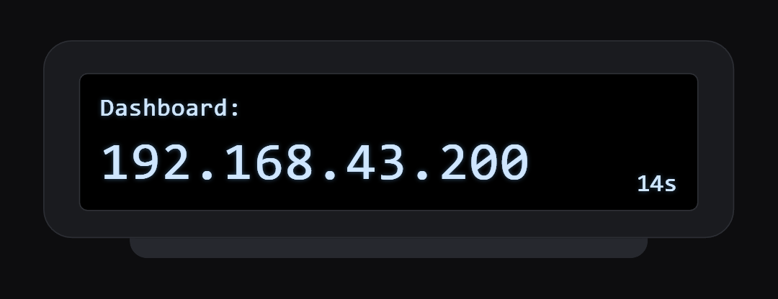
Serial printing was moved out of the ESP-NOW receive callback into a drained queue. Printing inside the callback blocks the WiFi task long enough to drop the following packets, which made a healthy radio link look unreliable.

Week 5 — Companion dashboard and data logging
Planned: a companion app or dashboard, GPS route mapping, ride statistics, a post-ride summary and live sync.
Delivered: a dashboard served by the board itself over the phone hotspot, with a live map, session recording, a post-ride summary covering distance, top speed, wobble alerts and trick counts, and per-session downloads.
The board joins the rider's phone hotspot, takes a DHCP lease, then moves itself to <subnet>.200 and verifies the move, so the dashboard address is predictable on any phone. It also answers to skateguard.local, though phone support for that is inconsistent, which is why the wrist unit displays the numeric address.
The page is stored in flash inside the sketch and served whole; the browser polls /api/live twice a second.
Endpoint | Purpose
/ | The dashboard page
/api/live | Telemetry JSON, polled twice a second
/api/debug | Motion state machine, GPS, radio and memory values
/api/sessions | Saved sessions and their routes
/api/command?cmd= | start, stop, save, discard, delete:<n>
/log, /clear | Download or clear the motion log
/manifest.json | Web app manifest for "Add to Home screen"
[image: The dashboard on the phone, waiting to record]
Stopping a ride does not save it: the card offers Save or Discard, and nothing is written until one is chosen. A saved ride stores its distance, average speed, top speed, land count, bail count and wobble-alert count. Saved rides go to LittleFS, the last 7 kept, with a route point every 30 seconds up to 20 points. Each row can be downloaded as a CSV of the ride plus a rendered PNG of its route, drawn in the browser over OpenStreetMap tiles.
Route line N belongs to session N, with a - placeholder for rides recorded without GPS. An earlier version skipped those blank lines, which slid every later route onto the wrong session.

Week 6 — Testing, tuning and demonstration
Planned: full system testing across speeds and surfaces, tuning to cut false triggers, final assembly, demonstration and documentation.
Delivered so far: both units assembled and running, with bench, browser and first field testing complete. On-road tuning and the demonstration are the remaining work.
Testing so far covers the sensors, the radio and the dashboard. Detection accuracy on real rides has not been quantified yet; that is the open item.
Area | Method | Result
Trick detection | stage_log.csv, a row every 500 ms holding stage, all three gyro axes, accumulated degrees, each window against its limit and the event that fired | Thresholds set to the values in the table above; log downloads cleanly and is capped at 2000 rows
Loop health | Slowest and average loop period recorded and shown on the debug page | Instrumented, because a stalled loop shows up as missed tricks rather than as a timing symptom
GPS | Status line every 5 seconds: satellites, HDOP, characters processed, fix age, checksum failures; first fix after boot timed | Fix acquired outdoors with 4 or more satellites; no fix indoors, as expected
Radio link | Power-up in both orders, walking out of range until NO SIGNAL and back, changing the hotspot so the channel moves | Wrist unit re-finds the board without a reboot in each case
Dashboard | Exercised in a browser against a simulated board: save and discard, the 7-session cap, deleting sessions, downloads with and without a route | All paths work; the route-alignment fault was reproduced and fixed with a no-GPS session saved between two GPS sessions
Field use | Real rides recorded, then opened as live map and session route maps | Routes render over OpenStreetMap tiles and match the ride
[image: A recorded session drawn over OpenStreetMap tiles]
What remains for Week 6 is riding sessions with a hand-counted tally of flips, so land and bail counts can be scored against what actually happened and the thresholds tuned to cut false triggers.

Changes from the original plan
Four decisions made during the build differ from the Week 1 plan. Each was a change of method, not of objective.
Planned | Built | Reason
MPU6050 IMU | BNO055 IMU | The BNO055 fuses on the sensor and outputs absolute orientation, so rotation is measured directly instead of being filtered on the ESP32 inside the control loop
BLE link to a companion app | ESP-NOW to the wrist unit, dashboard served by the board | A companion app has to be installed and kept in step with the firmware. A page served from the board opens in any phone browser, and ESP-NOW gives a board-to-wrist link with no pairing step
Wobble triggered above 25 km/h | Wobble from three counted oscillations, no speed gate | GPS speed needs 4 satellites and lags real movement, and wobble can start below 25 km/h. The oscillation pattern is the symptom itself, so it is what the detector watches
Bail detected from an accelerometer impact spike | Bail detected from how far the deck swings after the rotation | A clean landing can produce a sharp impact and a bail can produce none, so the spike does not separate them. The settling swing does
The 25 km/h figure is still usable as a reporting threshold rather than a trigger, if the project needs it stated that way, as a configurable alert level rather than a detection gate.

Limitations and next steps
- Detection is tuned for kickflips. Other tricks rotate around different axes and are not classified.
- The dashboard has no login. Anyone on the hotspot can open it, record and delete sessions; the hotspot password is the only barrier.
- A GPS cold start can take several minutes, and nothing is reported until 4 satellites are visible.
- Map tiles come from OpenStreetMap, so the phone needs internet for the map screens. Recording itself does not.
- The sketch fills 91% of the default 1.25 MB partition. Larger features need a different partition scheme, which erases stored sessions.
- Only the last 7 sessions are kept, and a route point every 30 seconds means the drawn line cuts corners on fast laps.
- Deleting a session happens immediately, with no confirmation.
Next steps, in order:
- Confirm the rotation axis from one real kickflip, comparing the three gyro axes now logged, and confirm the I2C and ADC pins from the boot log.
- Ride with a hand-counted tally of flips, score land and bail counts against it, and tune the thresholds using stage_log.csv to cut false triggers.
- Confirm the wobble oscillation count on a real speed wobble rather than a bench shake.
- Decide whether the 25 km/h figure returns as an alert level.
- Battery-life measurement for both units over a full session.

